The newcomers
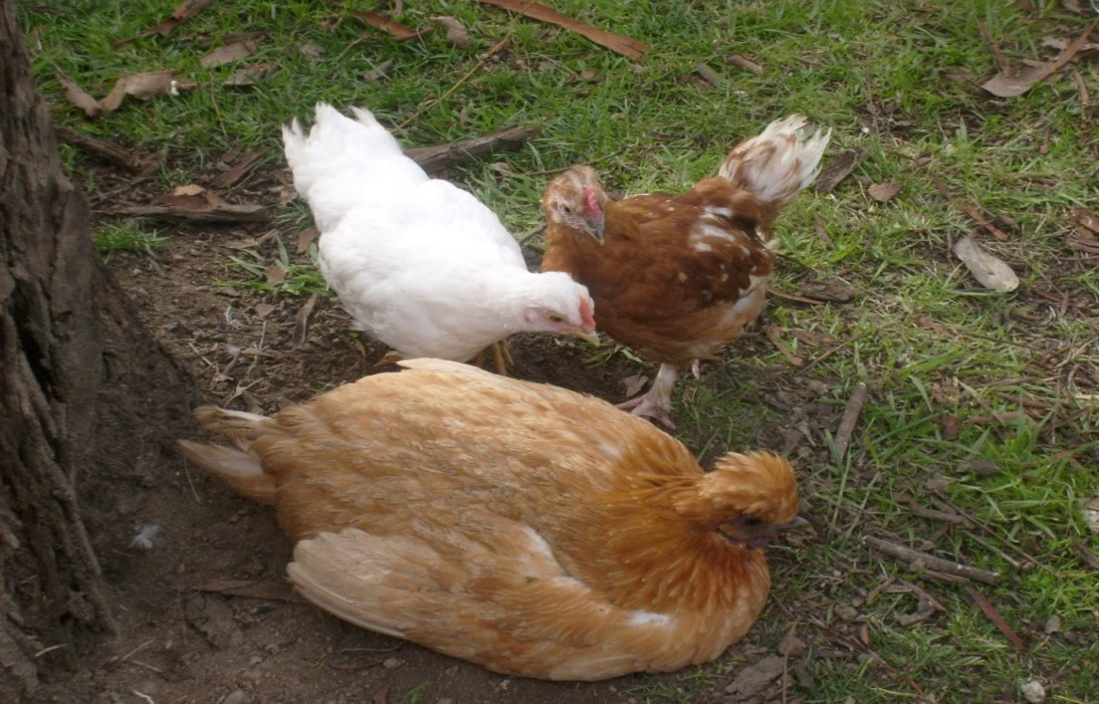
Millthorpe Public School has seen the arrival of some new students, but they’re not human students! The school has adopted some chickens and they’ve taken up residence between demountable two and demountable three. 2B, whose classroom is demountable two, have been enjoying watching the new arrivals. Emma likes the friendliness and chatty nature of the chooks and Taylah likes how cute the baby ones are. A competition was run to name the two youngest chooks and the winning names were Pudding and Sunny. The mother hen is named Megapenny. As chief chook manager my job is to feed the chooks, let them out every morning and make sure they’re tucked in safely at night. The chooks feed on seed and crumble. They have a protective fence so that they don’t get too much love from the students, or eaten by the foxes. I think the chooks are a great addition to Millthorpe Public School. Not only are they relaxing to watch, but they are also education for the kids. Welcome to the newcomers and make sure you go and say g’day!
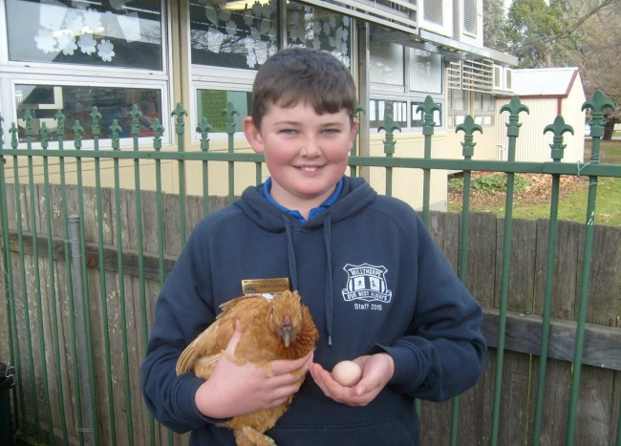
The first egg!
It was laid on the 12/6/15

